Employee Management System

Black-Box Testing

1. Equivalence Partitioning (EP)

Module 1 — Add Employee
TC# | Field | Valid Class | Invalid Class | Test Input | Expected Result
EP-A01 | Employee ID | Positive integer | Negative value | -1 | Employee should not be accepted
EP-A02 | Employee ID | Positive integer | Zero | 0 | Employee should not be accepted
EP-A03 | Name | Non-empty text | Empty name | “” | Employee should not be accepted
EP-A04 | Name | Text up to 19 chars | Very long name | “VeryLongEmployeeName123” | Input should be restricted/handled
EP-A05 | Salary | Positive number | Negative salary | -5000 | Employee should not be accepted
EP-A06 | All fields | Valid ID, name, salary | — | 1, Ali, 50000 | Employee added successfully

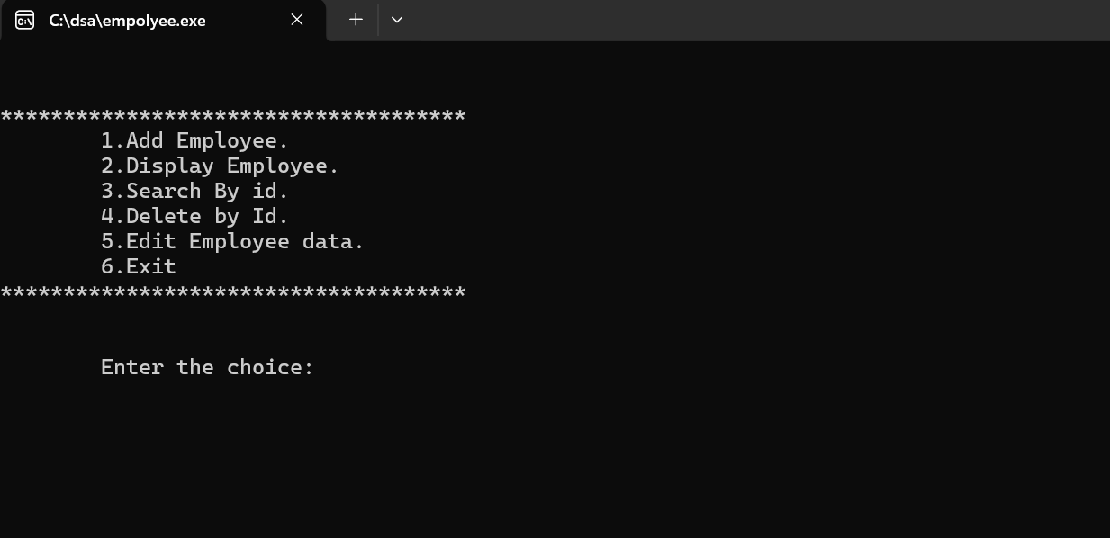
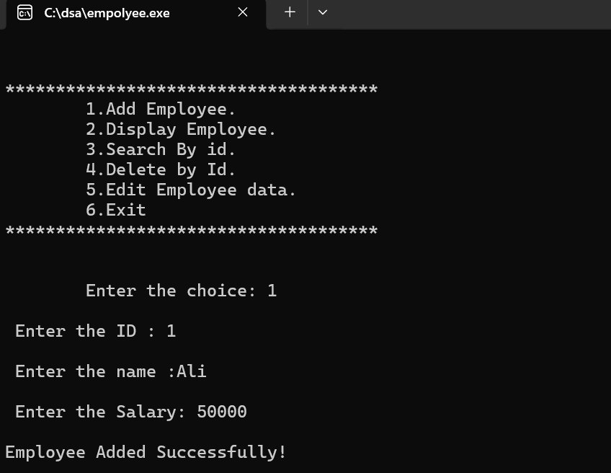

Module 2 — Display Employee
TC# | Condition | Test Input | Expected Result
EP-D01 | No employee exists | Select Display | “No employee data here”
EP-D02 | One employee exists | Add 1 employee then display | One employee record displayed
EP-D03 | Multiple employees exist | Add 3 employees then display | All employees displayed
EP-D04 | Employee has valid salary | Salary = 50000 | Salary displayed correctly
EP-D05 | Employee has long name | Name near max length | Name displayed without crash

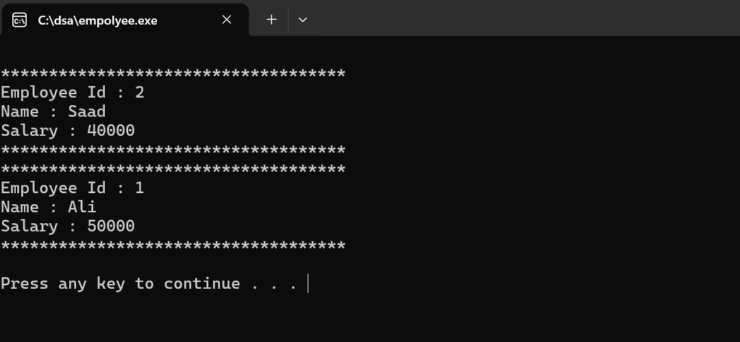

Module 3 — Search Employee by ID
TC# | Field | Valid Class | Invalid Class | Test Input | Expected Result
EP-S01 | ID | Existing ID | — | 1 | Employee Found
EP-S02 | ID | — | Non-existing ID | 99 | Employee is not Found
EP-S03 | ID | — | Negative ID | -5 | Employee is not Found
EP-S04 | ID | — | Zero | 0 | Employee is not Found
EP-S05 | List | Empty list | — | Search any ID | Not Found

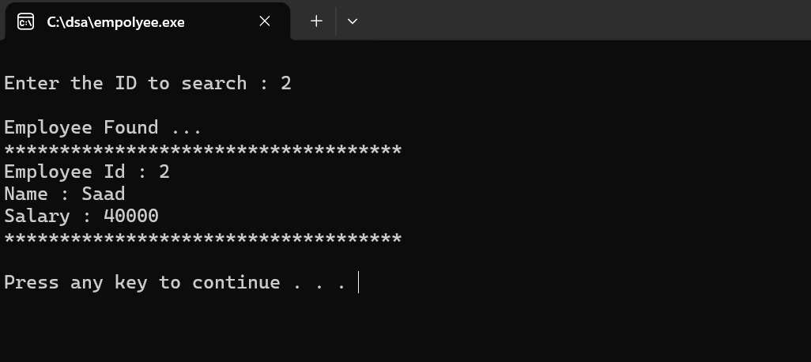
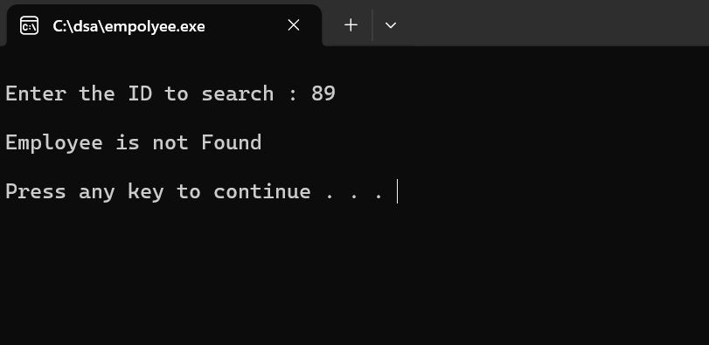

Module 4 — Delete Employee by ID
TC# | Condition | Test Input | Expected Result
EP-DEL01 | Delete from empty list | ID = 1 | “No employee data is here”
EP-DEL02 | Delete first employee | First node ID | Employee deleted
EP-DEL03 | Delete middle employee | Middle ID | Employee deleted
EP-DEL04 | Delete last employee | Last ID | Employee deleted
EP-DEL05 | Delete non-existing employee | ID = 99 | “not Found”

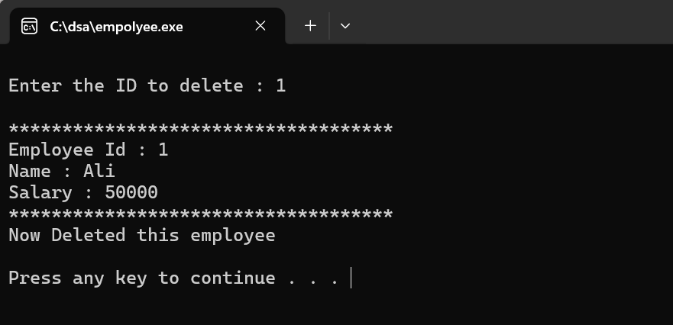

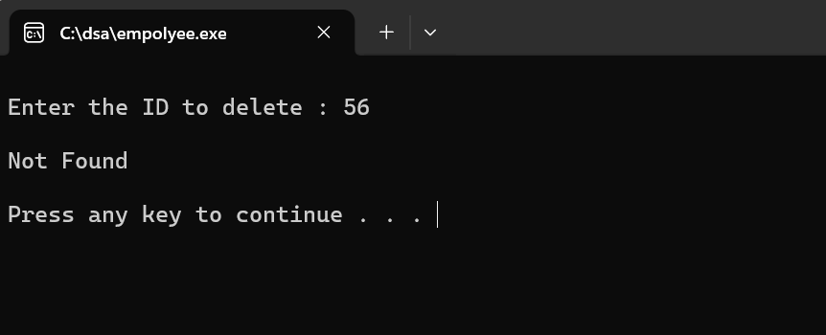

Module 5 — Edit Employee Data
TC# | Condition | Test Input | Expected Result
EP-E01 | Existing employee | ID = 1 | Edit options shown
EP-E02 | Non-existing employee | ID = 99 | “Record not Found”
EP-E03 | Change name only | Y for name, N for salary | Name updated
EP-E04 | Change salary only | N for name, Y for salary | Salary updated
EP-E05 | Change both | Y for both | Name and salary updated
EP-E06 | Empty list | Edit any ID | “No Employee is here”

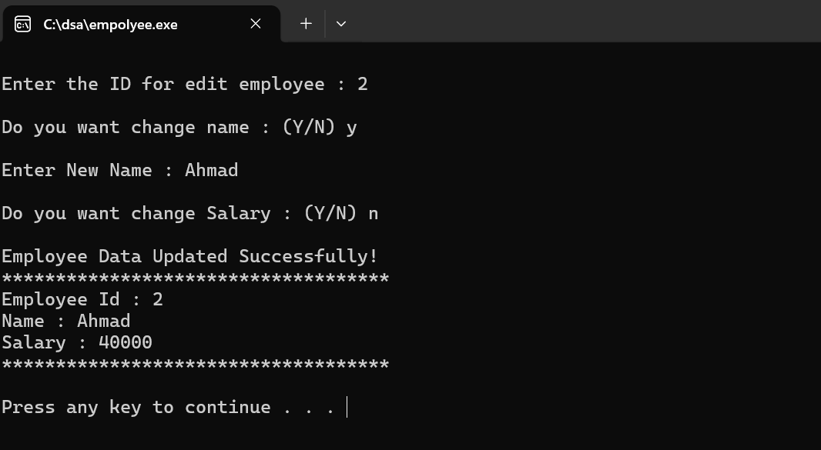

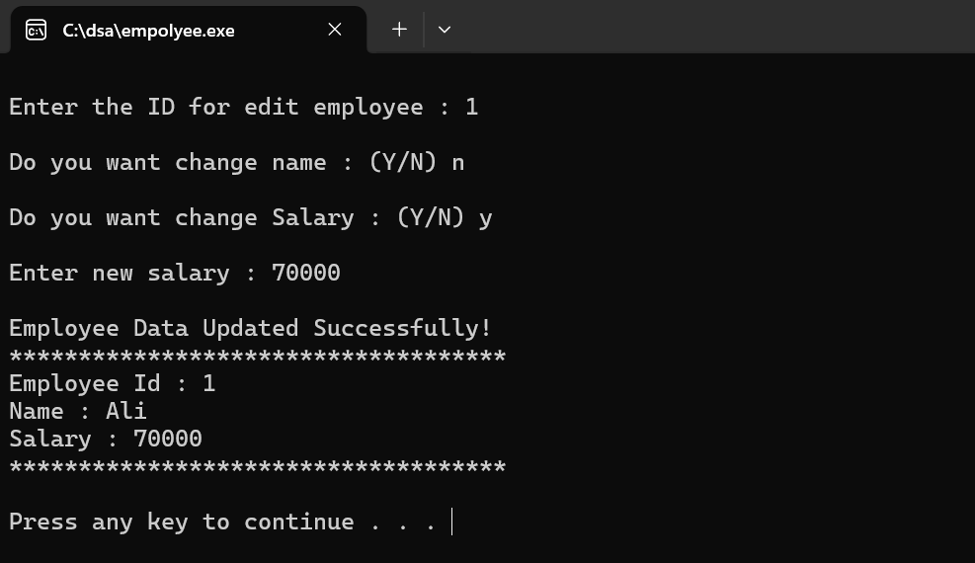

2. Boundary Value Analysis (BVA)

Module 1 — Employee ID Boundaries
TC# | Boundary Type | Test Value | Expected Result
BV-ID01 | Below minimum | -1 | Invalid / should not be accepted
BV-ID02 | At minimum invalid | 0 | Invalid / should not be accepted
BV-ID03 | First valid value | 1 | Employee accepted
BV-ID04 | Typical valid value | 50 | Employee accepted
BV-ID05 | Large valid value | 9999 | Employee accepted or handled

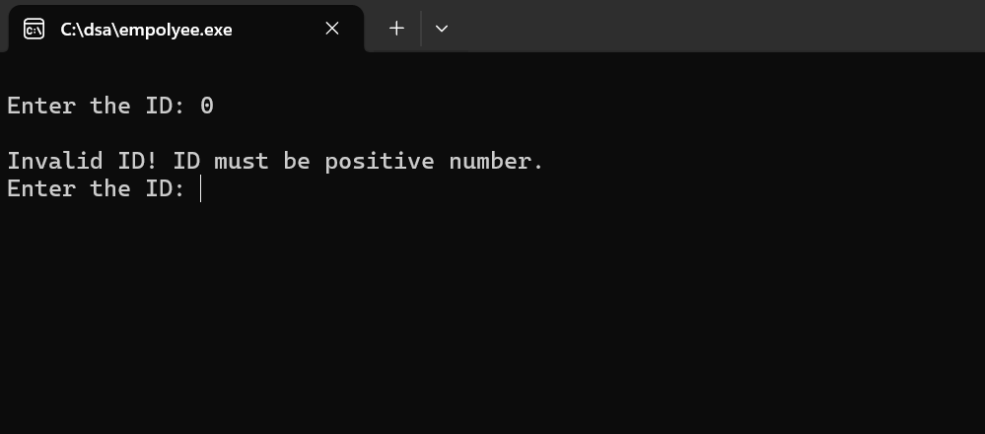
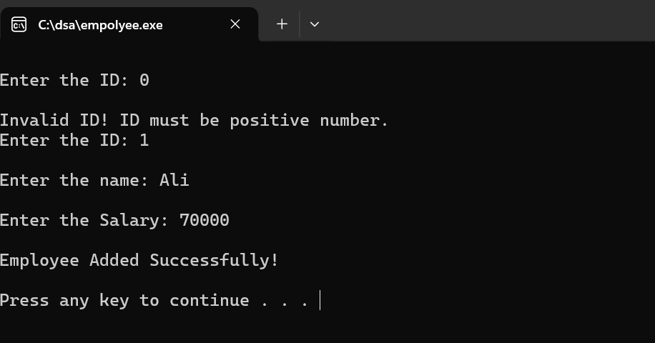

Module 2 — Name Length Boundaries
TC# | Boundary Type | Test Value | Expected Result
BV-N01 | Empty name | “” | Should not be accepted
BV-N02 | Minimum valid | “A” | Accepted
BV-N03 | Typical valid | “Ali” | Accepted
BV-N04 | Maximum safe length | 19 characters | Accepted
BV-N05 | Above limit | 20+ characters | Should be restricted/handled

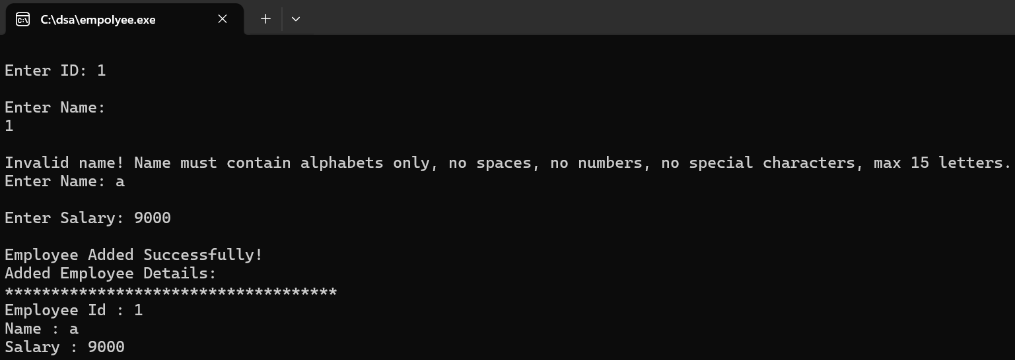
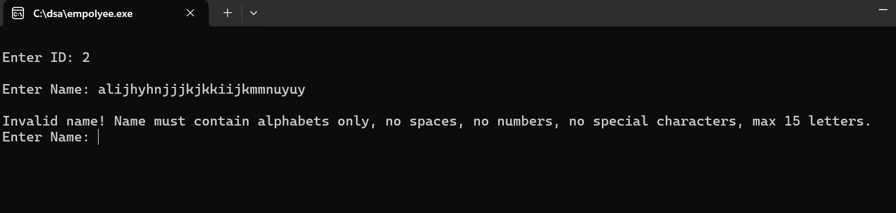

Module 3 — Salary Boundaries
TC# | Boundary Type | Test Value | Expected Result
BV-SAL01 | Below minimum | -1 | Invalid
BV-SAL02 | Zero salary | 0 | Should be invalid or handled
BV-SAL03 | Just above zero | 0.1 | Accepted
BV-SAL04 | Typical salary | 50000 | Accepted
BV-SAL05 | Large salary | 999999 | Accepted or handled

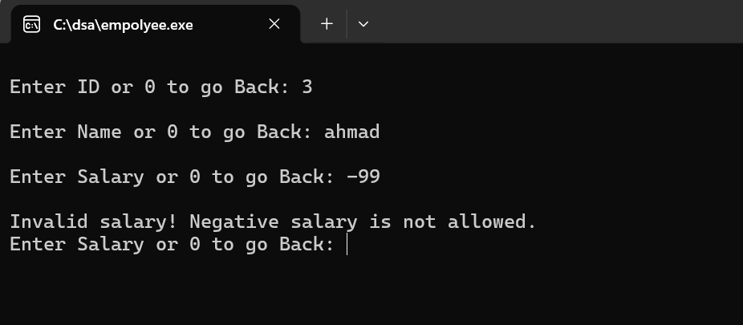
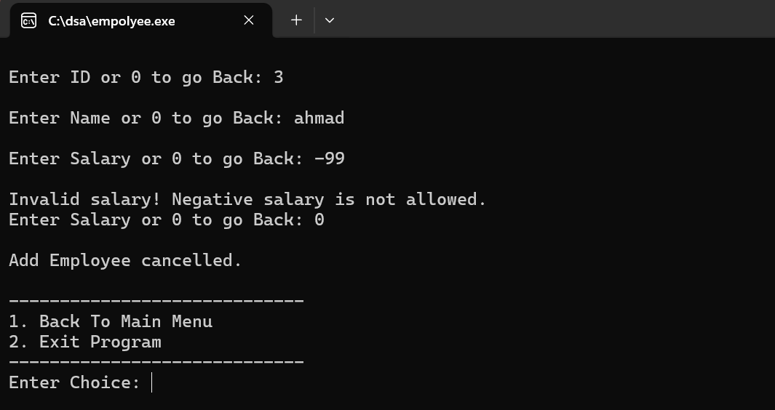

Module 4 — Menu Choice Boundaries
TC# | Boundary Type | Test Value | Expected Result
BV-M01 | Below menu range | 0 | Invalid choice
BV-M02 | First valid option | 1 | Add Employee opens
BV-M03 | Middle valid option | 3 | Search option opens
BV-M04 | Last valid option | 6 | Program exits
BV-M05 | Above menu range | 7 | Invalid choice

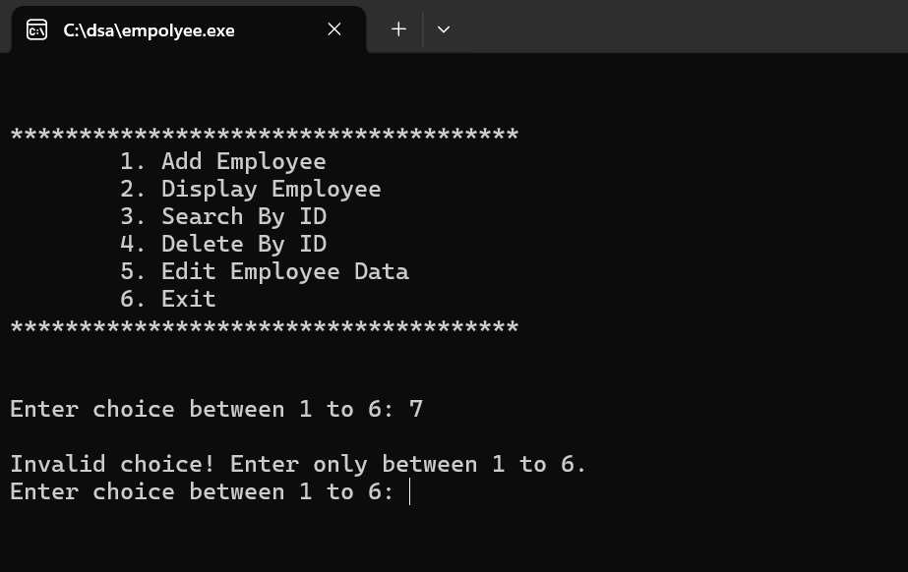

3. Decision Table Testing
Decision Table Testing multiple conditions ke combination ko test karta hai.

Module 1 — Add Employee Decision Table
Condition / Action | R1 | R2 | R3 | R4
ID valid? | Y | N | Y | Y
Name valid? | Y | Y | N | Y
Salary valid? | Y | Y | Y | N
Action: Add employee | Y | N | N | N
Action: Show/handle error | N | Y | Y | Y

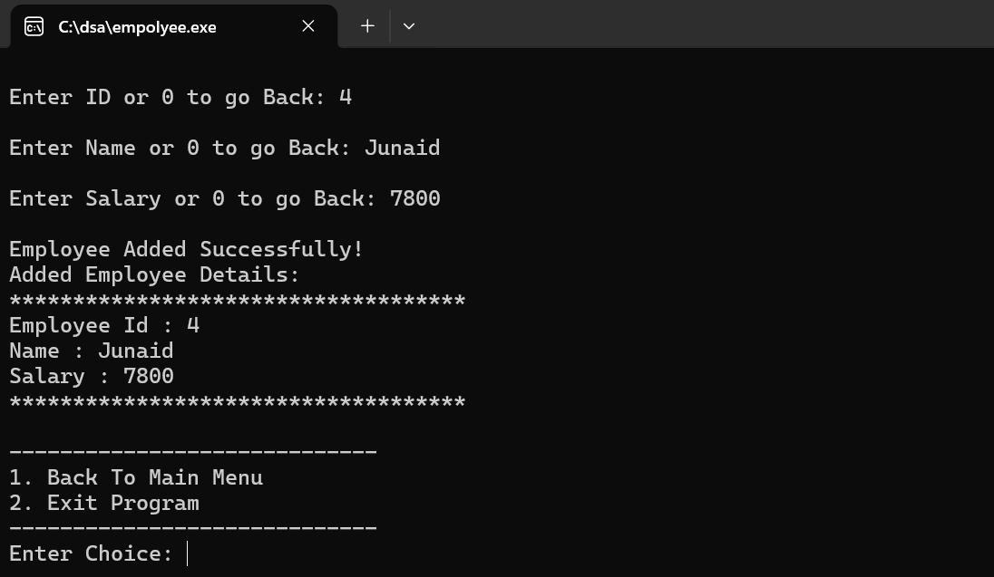

Module 2 — Search Employee Decision Table
Condition / Action | R1 | R2 | R3
Employee list empty? | N | N | Y
ID exists? | Y | N | —
Action: Display employee | Y | N | N
Action: Show not found | N | Y | Y

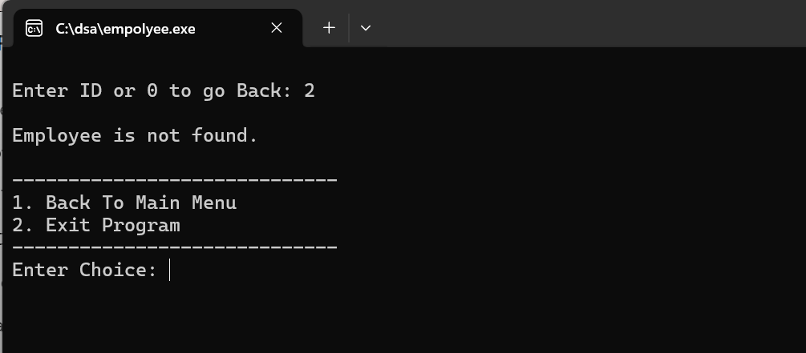

Module 3 — Delete Employee Decision Table
Condition / Action | R1 | R2 | R3 | R4
List empty? | Y | N | N | N
ID is first node? | — | Y | N | N
ID exists after first? | — | — | Y | N
Action: Delete employee | N | Y | Y | N
Action: Show not found/no data | Y | N | N | Y

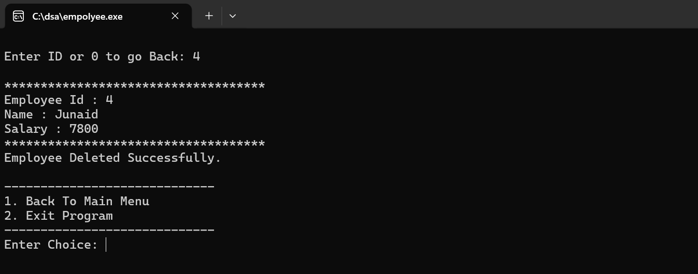

Module 4 — Edit Employee Decision Table
Condition / Action | R1 | R2 | R3
Employee exists? | Y | Y | Y
Change name? | Y | N | Y
Change salary? | N | Y | Y
Action: Update name | Y | N | Y
Action: Update salary | N | Y | Y
Action: Record not found | N | N | N

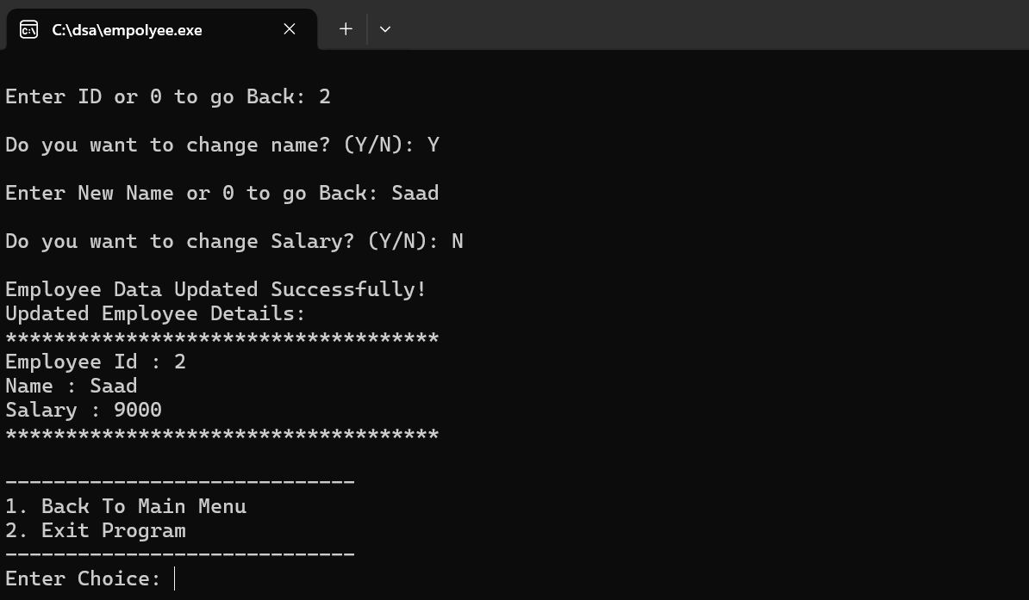

4. State Transition Testing

Employee Management System States
TC# | Current State | Event | Next State | Expected Output
ST-01 | Program Started | Menu displayed | Waiting for choice | User can select option
ST-02 | Empty List | Add Employee | Employee Added | Record stored in linked list
ST-03 | Employee Added | Display Employee | Display State | Employee details shown
ST-04 | Employee Added | Search existing ID | Found State | Employee Found
ST-05 | Employee Added | Search wrong ID | Not Found State | Employee is not Found
ST-06 | Employee Added | Edit Employee | Updated State | Employee data updated
ST-07 | Employee Added | Delete Employee | Deleted State | Employee removed
ST-08 | Empty List | Delete Employee | Empty State | No employee data is here
ST-09 | Any State | Select Exit | Program End | End the Program

5. Cause–Effect Graphing / Functional Scenarios
TC# | Module | Cause | Effect | Test Scenario
CE-01 | Add Employee | Valid ID, valid name, valid salary | Employee added | Enter 1, Ali, 50000
CE-02 | Add Employee | Invalid salary | Employee should not be accepted | Enter salary -5000
CE-03 | Display | No employee exists | No data message | Select Display before adding
CE-04 | Display | Employee exists | Employee details shown | Add employee then display
CE-05 | Search | ID exists | Employee Found | Search ID 1
CE-06 | Search | ID does not exist | Not Found | Search ID 99
CE-07 | Delete | ID exists | Employee deleted | Delete ID 1
CE-08 | Delete | Empty list | No employee data message | Delete before adding
CE-09 | Edit | ID exists and name changed | Name updated | Edit employee name
CE-10 | Edit | ID exists and salary changed | Salary updated | Edit employee salary
CE-11 | Menu | Invalid choice entered | Invalid choice message | Enter 9
CE-12 | Exit | Choice 6 selected | Program ends | Select Exit

6. Summary
This black-box testing document covers the Employee Management System using major black-box testing techniques: Equivalence Partitioning, Boundary Value Analysis, Decision Table Testing, State Transition Testing, and Cause–Effect Graphing. The testing focuses only on inputs and outputs of the system without checking internal implementation. These test cases provide strong functional coverage for adding, displaying, searching, deleting, editing employees, and handling menu choices.

